Mark W. Newman, James A. Landay.(2000). *Sitemaps, Storyboards, and Specifications: A Sketch of Web Site Design Practice.* [PDF] Berkeley: University of California. Available at: [Accessed 31 September 2016].

(Newman and Landay, 2000)

Pg 263

The study interviewed eleven designers involved in the web site design process with different levels of experiences.

Pg 264

Information design: refer to the problem of identifying groups of related content and structuring information into a coherent whole.

Navigation design: refers to the design of methods of dinging one’s way around the information structure.

Graphic design/visual design: *refers to the visual communication of information using elements such as color, images, typography, and layout.*

Information and navigation design focus on the entire website and the relationship between latge-scale elements such as pages within the site

Graphic design focuses primarily on the presentation of individual elements.

Information architecture: an emerging specialty within website design that refers primarily to the combination of information and navigation design.

User interface design: refers primarily to the design of navigation systems, with some overlap into information design and graphic design.

Pg265

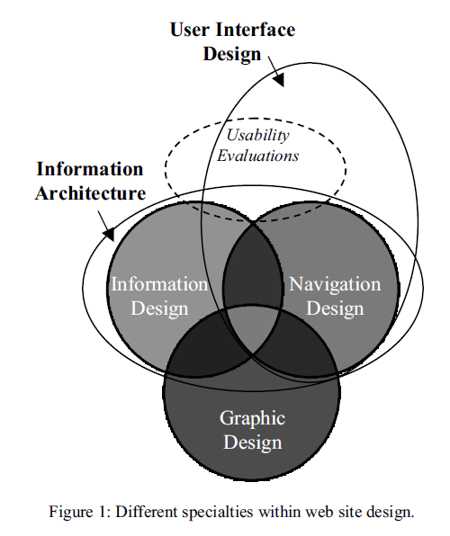

Pg267